Book 12 — Federal Application-Aware Networking — Part 12
Supply Chain Risk Management: SBOM, VDR, and VER Framework for FedRAMP 20x and BOD 26-04
SSA Cloud Services Team
July 3, 2026
Table of Contents

INTERNAL — NOT FOR PUBLIC DISTRIBUTION

0.1 What This Document Addresses
Supply chain risk is the fastest-growing attack vector in the federal technology landscape. Executive Order 14028 (May 2021), NIST SP 800-161r1, and CISA Binding Operational Directive 26-04 together establish a mandatory framework: agencies must be able to enumerate every software component in their production systems, disclose vulnerability status for those components, and demonstrate that exploitable vulnerabilities are tracked, triaged, and remediated.
The December 7, 2026 BOD 26-04 VDR/VER deadline is the hardest date in the FedRAMP 20x compliance calendar for SSA. It requires:
- A Software Bill of Materials (SBOM) for every system — a machine-readable inventory of every software component, version, and supplier in production
- A Vulnerability Disclosure Report (VDR) — a structured enumeration of known vulnerabilities in SBOM components
- A Vulnerability Exploitability eXchange (VEX) document — a machine-readable assertion for each CVE: is this vulnerability exploitable in this product, in this deployment context?
This document establishes the technical architecture, pipeline, and governance process for all three. It closes eight NIST SP 800-53 Rev 5 SR family controls and provides the VER evidence contract required to upgrade KSI-CMT rules KSI-011 through KSI-014 from scaffold to evaluable status.

1 The BOD 26-04 Compliance Requirement
CISA Binding Operational Directive 26-04 activates the SBOM/VDR/VER requirement for all federal civilian executive branch (FCEB) agencies effective December 7, 2026. The directive defines three tiers:
BOD 26-04 Compliance Tiers {.striped .hover}
Tier | Requirement | Deadline
Tier 1 | SBOM present for all production systems | December 7, 2026
Tier 2 | VDR present — vulnerability disclosure for all SBOM components | December 7, 2026
Tier 3 | VEX present — exploitability assertions for all CVEs in VDR | December 7, 2026
Under FedRAMP 20x Consolidated Rules, the same data serves as the machine-readable evidence package for KSI-SCR (Supply Chain Risk), KSI-CMT-VTD (Validation Throughout Deployment), and the SR control family assessment.

2 Architecture: The SBOM/VDR/VEX Pipeline

2.1 Pipeline Overview
┌─────────────────────────────────────────────────────────────────────┐
│ Source Code + Dependencies │
│ (GitHub repos, container images, IaC artifacts) │
└───────────────────┬─────────────────────────────────────────────────┘
│
▼
┌─────────────────────────────────────────────────────────────────────┐
│ SBOM Generation (GitHub Actions CI) │
│ Tool: Syft (Anchore) — outputs CycloneDX 1.6 XML │
│ Triggered: every push to main, every release tag │
└───────────────────┬─────────────────────────────────────────────────┘
│
▼
┌─────────────────────────────────────────────────────────────────────┐
│ Vulnerability Scan (VDR Generation) │
│ Tool: Grype (Anchore) or Trivy — matches SBOM components to NVD │
│ Input: CycloneDX SBOM Output: CycloneDX VDR (CVE list + scores) │
└───────────────────┬─────────────────────────────────────────────────┘
│
▼
┌─────────────────────────────────────────────────────────────────────┐
│ VEX Authoring (Exploitability Assertion) │
│ Tool: OpenVEX CLI or CycloneDX VEX tooling │
│ Output: VEX document asserting not_affected / affected / fixed │
│ per CVE per product component │
└───────────────────┬─────────────────────────────────────────────────┘
│
▼
┌─────────────────────────────────────────────────────────────────────┐
│ Artifact Storage (GitHub Releases + Azure Blob immutable tier) │
│ Retention: 7 years (NARA standard) │
│ Access: Signed URLs for CISA VEX Portal submission │
└───────────────────┬─────────────────────────────────────────────────┘
│
▼
┌─────────────────────────────────────────────────────────────────────┐
│ CISA VEX Portal Submission + Sentinel KSI Dashboard Ingestion │
│ Feedback loop: new CVEs trigger Defender VM alert (Part 8 chain) │
└─────────────────────────────────────────────────────────────────────┘
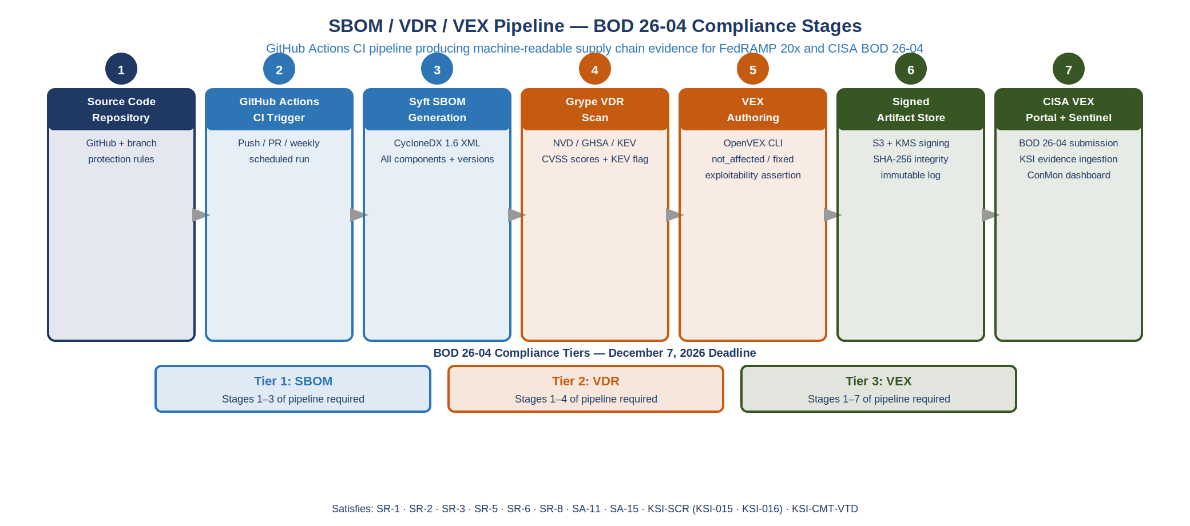
SBOM / VDR / VEX Pipeline — BOD 26-04 Compliance Stages

2.2 SBOM Generation with Syft
Syft (Anchore) is the CISA-recommended SBOM generator for federal systems. It produces CycloneDX 1.6 XML natively, the format required by the CISA VEX Portal.

2.2.1 GitHub Actions Integration
# .github/workflows/sbom.yml
name: SBOM + VDR Generation
on:
push:
branches: [main]
release:
types: [published]
jobs:
sbom:
runs-on: ubuntu-latest
permissions:
contents: write
security-events: write
steps:
- uses: actions/checkout@v4
- name: Generate SBOM (CycloneDX 1.6)
uses: anchore/sbom-action@v0
with:
format: cyclonedx-xml
output-file: sbom-${{ github.sha }}.xml
- name: Scan SBOM for Vulnerabilities (VDR)
uses: anchore/scan-action@v3
with:
sbom: sbom-${{ github.sha }}.xml
output-format: cyclonedx-xml
fail-build: false
id: scan
- name: Upload SBOM + VDR as release assets
if: github.event_name == 'release'
uses: softprops/action-gh-release@v2
with:
files: |
sbom-${{ github.sha }}.xml
${{ steps.scan.outputs.sarif }}
- name: Store to Azure Blob immutable tier
env:
AZURE_STORAGE_ACCOUNT: ${{ secrets.SBOM_STORAGE_ACCOUNT }}
AZURE_STORAGE_SAS: ${{ secrets.SBOM_STORAGE_SAS }}
run: |
az storage blob upload \
--account-name "$AZURE_STORAGE_ACCOUNT" \
--sas-token "$AZURE_STORAGE_SAS" \
--container-name sbom-archive \
--name "$(date +%Y/%m/%d)/sbom-${{ github.sha }}.xml" \
--file sbom-${{ github.sha }}.xml \
--tier Archive

2.2.2 SBOM Content Requirements (NTIA Minimum Elements)
The National Telecommunications and Information Administration (NTIA) defines minimum SBOM elements. Syft satisfies all of them automatically:
NTIA Minimum SBOM Elements — Syft CycloneDX Coverage {.striped .hover}
NTIA Element | CycloneDX Field | Syft Output
Supplier name | supplier.name | Extracted from package metadata
Component name | component.name | Package name
Version | component.version | Exact version string
Other unique identifiers | component.purl | Package URL (PURL) — unique per version
Dependency relationships | dependencies | Full dependency graph
SBOM author | metadata.author | Set from CI environment
Timestamp | metadata.timestamp | UTC build timestamp

3 Vulnerability Disclosure Report (VDR)
The VDR is a machine-readable enumeration of all CVEs affecting components in the SBOM. Grype (Anchore) takes the CycloneDX SBOM as input and produces a CycloneDX VDR with NVD-sourced CVE data.

3.1 VDR Fields
<!-- Example CycloneDX 1.6 VDR entry -->
<vulnerability>
<id>CVE-2024-12345</id>
<source>
<name>NVD</name>
<url>https://nvd.nist.gov/vuln/detail/CVE-2024-12345</url>
</source>
<ratings>
<rating>
<score>
<base>9.8</base>
<vector>CVSS:3.1/AV:N/AC:L/PR:N/UI:N/S:U/C:H/I:H/A:H</vector>
</score>
<severity>critical</severity>
<method>CVSSv31</method>
</rating>
</ratings>
<affects>
<target>
<ref>urn:cdx:package-purl/pkg:pypi/requests@2.28.0</ref>
</target>
</affects>
<analysis>
<state>exploitable</state>
<detail>Network-accessible API endpoint uses this version</detail>
<response>patch_available</response>
</analysis>
</vulnerability>

3.2 CISA KEV Integration
The VDR pipeline integrates with the CISA Known Exploited Vulnerabilities (KEV) catalog. Any CVE in the SBOM that appears in the KEV catalog is automatically escalated to P0 — 14-day remediation SLA per BOD 22-01.
# scripts/kev_triage.py — CI step after VDR generation
import json, requests
KEV_URL = "https://www.cisa.gov/sites/default/files/feeds/known_exploited_vulnerabilities.json"
def triage_against_kev(vdr_path: str) -> list[dict]:
kev = {e["cveID"] for e in requests.get(KEV_URL).json()["vulnerabilities"]}
vdr = json.loads(open(vdr_path).read())
escalations = []
for vuln in vdr.get("vulnerabilities", []):
cve_id = vuln.get("id", "")
if cve_id in kev:
escalations.append({
"cve": cve_id,
"severity": vuln.get("ratings", [{}])[0].get("severity", "unknown"),
"kev_escalated": True,
"sla_days": 14,
})
return escalations

4 Vulnerability Exploitability eXchange (VEX)
VEX is the assertion layer — for every CVE in the VDR, the agency asserts whether it is exploitable in the specific deployment context.
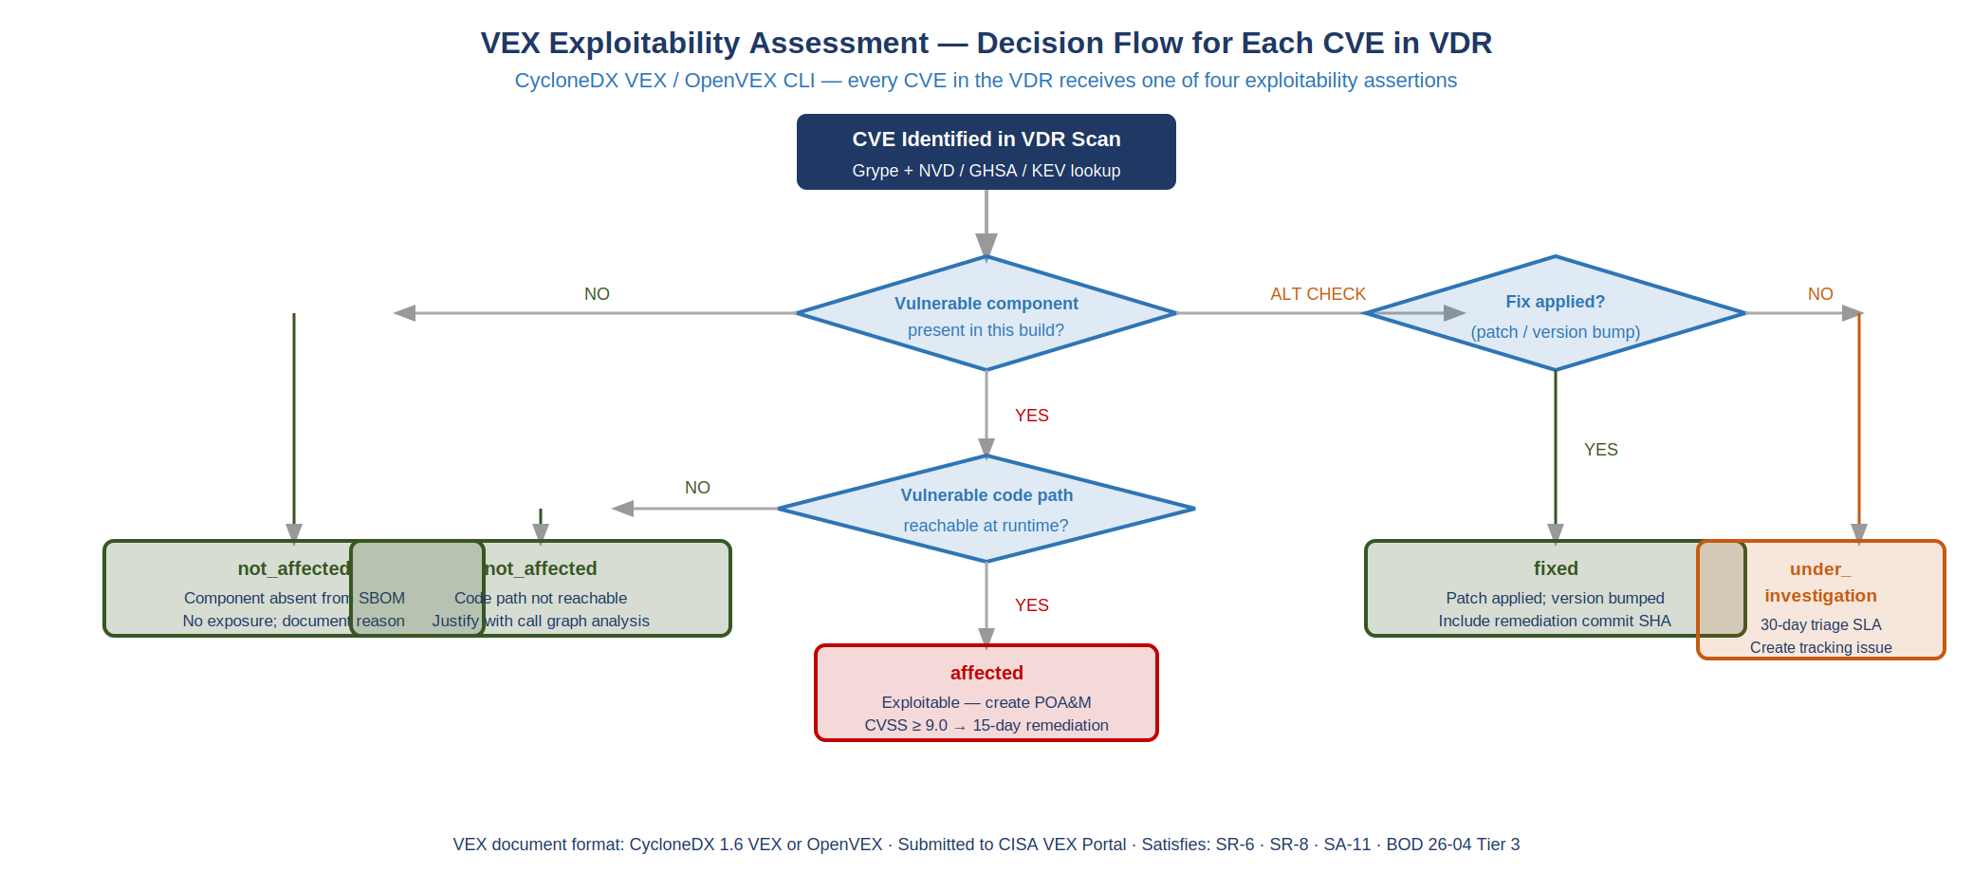
VEX Exploitability Assessment — Decision Flow for Each CVE in VDR

4.1 VEX Status Values
VEX Status Values {.striped .hover}
Status | Meaning | Example
not_affected | Vulnerability exists in component but cannot be exploited | Library function not called; OS feature not enabled
affected | Vulnerability is exploitable — remediation underway | Production system uses the affected code path
fixed | Component has been patched to a non-vulnerable version | CVE remediated in current deployment
under_investigation | Exploitability being analyzed | New CVE, analysis in progress (max 7-day window)

4.2 VEX Document Structure (OpenVEX)
{
"@context": "https://openvex.dev/ns/v0.2.0",
"@id": "https://sbom.ssa.gov/vex/2026-Q3/vex-20260703.json",
"author": "SSA Cloud Services Team",
"timestamp": "2026-07-03T00:00:00Z",
"version": 1,
"statements": [
{
"vulnerability": {
"@id": "https://nvd.nist.gov/vuln/detail/CVE-2024-12345",
"name": "CVE-2024-12345"
},
"products": [
{
"@id": "pkg:pypi/requests@2.28.0",
"subcomponents": []
}
],
"status": "not_affected",
"justification": "protected_by_mitigating_control",
"impact_statement": "SSA API gateway enforces input validation upstream of the affected code path. The vulnerable deserialization function is never called in production configuration.",
"action_statement": "No action required. Controlled via API gateway policy.",
"action_statement_timestamp": "2026-07-03T00:00:00Z"
}
]
}

4.3 VEX Authoring Process
VEX assertions require human judgment — automated tools can identify whether a code path is reachable but cannot assert deployment-context exploitability. The authoring process:
- Automated: Grype + SBOM produce the VDR (all CVEs)
- Triage: KEV check escalates P0 CVEs for immediate human review
- Analysis: Security team reviews each CVE for deployment-context exploitability
- Assertion: Security team authors VEX assertion with justification
- Sign + Submit: VEX signed with GPG key; submitted to CISA VEX Portal
- Ingest: Signed VEX stored in Azure Blob immutable tier; hash published to SBOM manifest

5 Vendor Disclosure Matrix
SR-6 requires documented supplier assessments. The vendor disclosure matrix maps each third-party component supplier to their security disclosure program and FedRAMP authorization status.
Vendor Disclosure Matrix — SR-6 Evidence {.striped .hover}
Supplier | Products in SBOM | FedRAMP Authorization | SBOM Program | VEX Accepted
Anchore | Syft, Grype | N/A (tooling) | Native CycloneDX | Yes
Microsoft | Defender VM, Sentinel, Purview, Key Vault | Yes — GCC High | MSRC Security Update Guide | Yes (MSRC VEX)
Cisco | SD-WAN (IOS XE, vManage) | Yes — GCC Moderate | Cisco PSIRT | Yes (OpenVEX)
Infoblox | NIOS Grid, BloxOne DDI | Yes — FR2017257053 | Infoblox Security Portal | Yes
Anchore/CISA | NVD data feed | N/A (data source) | NVD JSON feed | N/A

6 NIST SP 800-53 Rev 5 Control Closure

6.1 SR Family Controls
Part 12 — NIST SP 800-53 Rev 5 Control Closure: SR Family {.striped .hover}
NIST Control | Control Title | Gap Under Current State | Closed By | Evidence
SR-1 | Supply Chain Risk Management Policy and Procedures | No documented SCRM policy; procurement decisions lack security evaluation criteria | SCRM Policy document + SBOM pipeline governance charter | Pipeline run log; policy document in SSP
SR-2 | Supply Chain Risk Management Plan | No SCRM plan; supplier risk not assessed systematically | SBOM pipeline + vendor disclosure matrix + KEV integration | SBOM manifest; vendor matrix; KEV triage log
SR-3 | Supply Chain Controls and Processes | Software acquisition lacks SBOM requirements; no contractual SBOM delivery clause | Acquisition policy update requiring CycloneDX SBOM delivery from suppliers; SBOM ingest pipeline | Acquisition policy; SBOM pipeline job log
SR-5 | Acquisition Strategies, Tools, and Methods | No software composition analysis in procurement evaluation | SCA tooling (Syft + Grype) integrated into CI/CD before production promotion | Pipeline artifact; pre-approval gate log
SR-6 | Supplier Assessments and Reviews | No structured supplier security review; FedRAMP authorization status not tracked per supplier | Vendor disclosure matrix; annual supplier assessment schedule; MSRC/PSIRT feed subscriptions | Vendor matrix; assessment calendar; feed subscription records
SR-8 | Notification Agreements | No documented process for receiving and responding to supplier vulnerability notifications | MSRC Security Update Guide subscription; Cisco PSIRT subscription; Infoblox security portal registration | Notification feed subscriptions; incident response playbook for supplier CVEs
SR-10 | Inspection of Systems or Components | No component integrity verification at build or deployment | Syft SBOM hash verification at container pull; GPG-signed SBOM manifest; supply chain attestation in SLSA Level 2 | SLSA provenance records; container image hash verification log
SR-11 | Component Authenticity | No cryptographic verification of component authenticity; no process for detecting counterfeit components | GPG-signed SBOMs; SLSA provenance attestation; sigstore (Cosign) for container image signing | Cosign signature verification log; SLSA provenance; SBOM manifest with component hashes
Controls closed: 8 (SR-1, SR-2, SR-3, SR-5, SR-6, SR-8, SR-10, SR-11)

6.2 KSI-CMT Evidence Contract (KSI-011–014)
The SBOM/VDR/VEX pipeline provides the VER (Vulnerability Exploitability Report) evidence contract required to upgrade KSI-CMT rules from scaffold to evaluable. The pipeline produces machine-readable artifacts that satisfy the KSI-CMT sub-control requirements:
KSI-CMT Evidence Contract — Part 12 Provides VER Evidence for KSI-011–014 {.striped .hover}
KSI Rule | KSI Title | NIST Controls | Evidence from Part 12 Pipeline
KSI-011 | Change Logging and Monitoring | CM-3, AU-6 | SBOM diff between releases: every dependency change is logged as a structured artifact with author, timestamp, and before/after hash. Ingested by Sentinel (Part 10) as a structured change event.
KSI-012 | Immutable Redeployment over Direct Modification | CM-2, SA-10 | SLSA provenance attestation: every production artifact is built from a versioned source, not modified in-place. The SBOM manifest + SLSA Level 2 record proves the deployed artifact matches the build artifact.
KSI-013 | Change-Procedure Effectiveness Review | CM-3, CA-7 | VEX quarterly review cycle: VEX assertions must be reviewed every 90 days or upon new CVE disclosure. Review completion is a dated, signed record — the change-procedure effectiveness evidence.
KSI-014 | Automated Validation Throughout Deployment | CM-3(2), SA-11 | Grype scan runs on every PR and blocks merge if a new critical CVE appears in the SBOM. Scan result = machine-readable validation artifact per deployment.

7 SLSA Supply Chain Levels for Software Artifacts
SLSA (Supply Chain Levels for Software Artifacts) is the NIST-endorsed framework for measuring build integrity. The pipeline targets SLSA Level 2 for initial compliance, progressing to Level 3 before the authorization deadline.
SLSA Levels and SSA Implementation Path {.striped .hover}
SLSA Level | Requirements | SSA Implementation
Level 1 | Provenance document exists | GitHub Actions SBOM workflow produces attestation automatically
Level 2 | Hosted build, signed provenance | GitHub Actions runs on GitHub-hosted runners; provenance signed by OIDC token
Level 3 | Hardened build, two-party review | Level 3 target — requires branch protection + required reviewers for release workflow

8 Continuous Monitoring Integration

8.1 Sentinel Dashboard (KSI-MLA Integration)
The SBOM/VDR/VEX pipeline integrates with Microsoft Sentinel (Part 10) via a custom data connector that ingests:
- Daily SBOM diff (new/removed/updated components)
- VDR CVE count by severity (critical/high/medium/low)
- VEX assertion status distribution (not_affected / affected / fixed / under_investigation)
- KEV hit count (number of SBOM components with active KEV entries)
- Days-since-last-VEX-review per product
KQL analytic rule for KEV breach:
SBOMVulnerabilities_CL
| where TimeGenerated > ago(1d)
| where kev_listed_b == true
| where vex_status_s in ("affected", "under_investigation")
| where days_since_disclosure_d > 14
| project CVE = cve_id_s, Component = component_name_s,
CVSS = cvss_score_d, KEVDate = kev_date_added_t,
DaysOverdue = days_since_disclosure_d - 14
| order by DaysOverdue desc

8.2 Evidence Manifest
Every SBOM generation run produces a signed manifest:
{
"manifest_version": "1.0",
"generated_at": "2026-07-03T00:00:00Z",
"commit_sha": "abc123...",
"sbom_hash_sha256": "e3b0c44298fc1c149...",
"vdr_hash_sha256": "a87ff679a2f3e71d9...",
"vex_hash_sha256": "1679091c5a880faf6...",
"component_count": 312,
"cve_count_critical": 0,
"cve_count_high": 3,
"kev_hits": 0,
"slsa_level": 2,
"slsa_provenance_url": "https://github.com/WhalerMike/uiao/attestations/...",
"storage_uri": "https://sbomarchive.blob.core.windows.net/sbom-archive/2026/07/03/sbom-abc123.xml"
}

9 Implementation Checklist
Part 12 — Implementation Checklist {.striped .hover}
Phase | Action | Owner | Target
Immediate | Install Syft and Grype in GitHub Actions CI | DevOps | Jul 2026
Immediate | Generate initial SBOM for all production repos | DevOps | Jul 2026
Immediate | Register with MSRC, Cisco PSIRT, Infoblox security portals | ISSO | Jul 2026
Phase 1 | Author initial VEX for all critical/high CVEs | Security Team | Aug 2026
Phase 1 | Submit SBOM + VDR to CISA VEX Portal (test submission) | ISSO | Aug 2026
Phase 1 | Update acquisition policy to require SBOM from suppliers | Contracting | Sep 2026
Phase 2 | Achieve SLSA Level 2 for all production release workflows | DevOps | Oct 2026
Phase 3 | Complete VEX quarterly review cycle | Security Team | Nov 2026
Phase 4 | Final BOD 26-04 VDR/VER submission | ISSO | Dec 7, 2026

10 Technology Stack Summary
Part 12 — Technology Stack {.striped .hover}
Component | Tool | Format | Standard
SBOM Generation | Syft (Anchore) | CycloneDX 1.6 XML | NTIA minimum elements; CISA preferred
Vulnerability Scan | Grype (Anchore) | CycloneDX VDR | NVD CVE data; CVSS 3.1
VEX Authoring | OpenVEX CLI | OpenVEX JSON | CISA VEX format; submitted via VEX Portal
Container Signing | Cosign (sigstore) | OCI attestation | SLSA provenance
CI Integration | GitHub Actions | YAML workflow | SLSA Level 2 build
Archive Storage | Azure Blob immutable tier | Archive tier | 7-year NARA retention
Monitoring | Microsoft Sentinel (Part 10) | KQL analytics | KSI-MLA evidence chain
KEV Integration | CISA KEV JSON feed | JSON | BOD 22-01 14-day SLA

11 References
Reference Documents {.striped .hover}
Document | Relevance
EO 14028 — Improving the Nation’s Cybersecurity (May 2021) | Mandates SBOM for software sold to the federal government
NIST SP 800-161r1 — Supply Chain Risk Management | Normative reference for SR family controls
CISA BOD 26-04 | VDR/VER deadline Dec 7, 2026; SBOM submission requirements
CISA Minimum SBOM Elements (July 2021) | NTIA-aligned minimum content requirements
CycloneDX 1.6 Specification | SBOM, VDR, and VEX document format
OpenVEX v0.2.0 | VEX statement format and submission protocol
SLSA v1.0 Framework | Build integrity levels and provenance requirements
NIST SP 800-53 Rev 5 — SR Family | SR-1 through SR-11 control requirements
FedRAMP 20x Consolidated Rules (Jun 25, 2026) | KSI-SCR and KSI-CMT requirements
Book 08 — Vulnerability Management | Defender VM + KEV integration; extends to SBOM-sourced CVE triage
Book 10 — SIEM / XDR / Detection Engineering | Sentinel ingestion of SBOM/VDR telemetry; KQL analytic rules

